Your AI Assistant Kit: 12 Practical Tools
Boost your creative work without the learning curve
A guest post by
Jeremy Caplan
of the Newsletter Wonder Tools.

Want some shortcuts to enhance your creative work and boost your productivity? Here are 12 useful AI tools that will help you clean up audio, design lively visuals, or gather quick info for anything you’re working on. You remain in charge — these services don’t replace you, they empower you. Each of these free or low-cost tools can save you time and expand the possibilities of what you can do at your desk.

Clean up your audio — Adobe Podcast v2
Upload audio files up to 30 mins and remove background noise. You can use this free tool to record and edit a 30-minute podcast. It’s a simpler alternative to Descript, which is what I use most often. More on what’s new in Adobe’s v2.

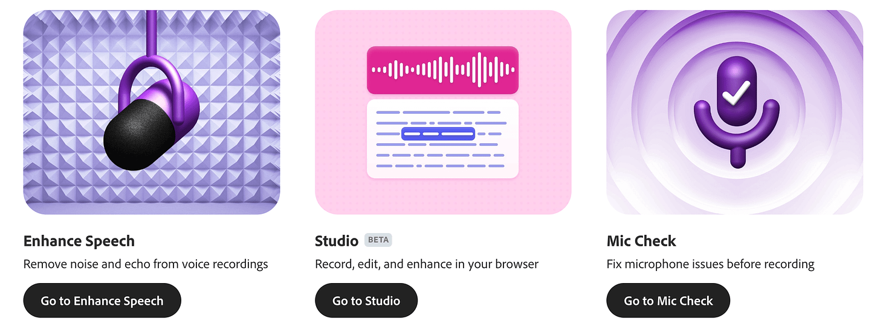

Remove a photo background — Adobe Express AI
Upload a photo (up to 40mb) and seconds later get a cutout with a blank background. You can download the image or add a background and other graphics with the Adobe Express editor.

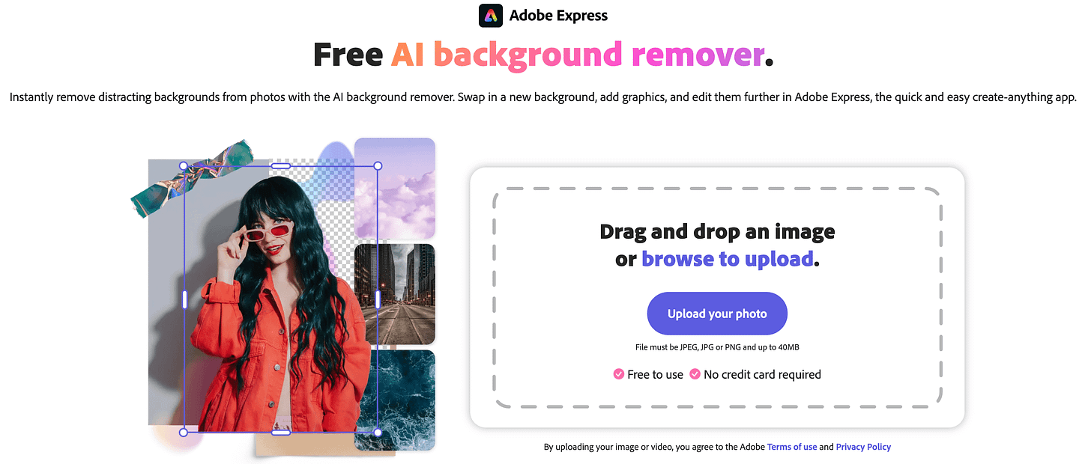

Train AI on your writing style — Claude
Give Claude a sample of your writing or describe your style. This new feature enables Claude to write an email, a meeting summary, or anything else in your style. Here’s Anthropic’s brief announcement.



Revitalize an old photo — Pica AI Photo Enhancer
Refresh any old photo. Pica will reduce blur, scratches and graininess. I tested it recently with a childhood picture. Get a few free watermarked restorations each day, or pay $40/year to subscribe. In my tests Remini appears to be a higher-quality, costlier alternative at $180/year. I also like Google’s free PhotoScan.

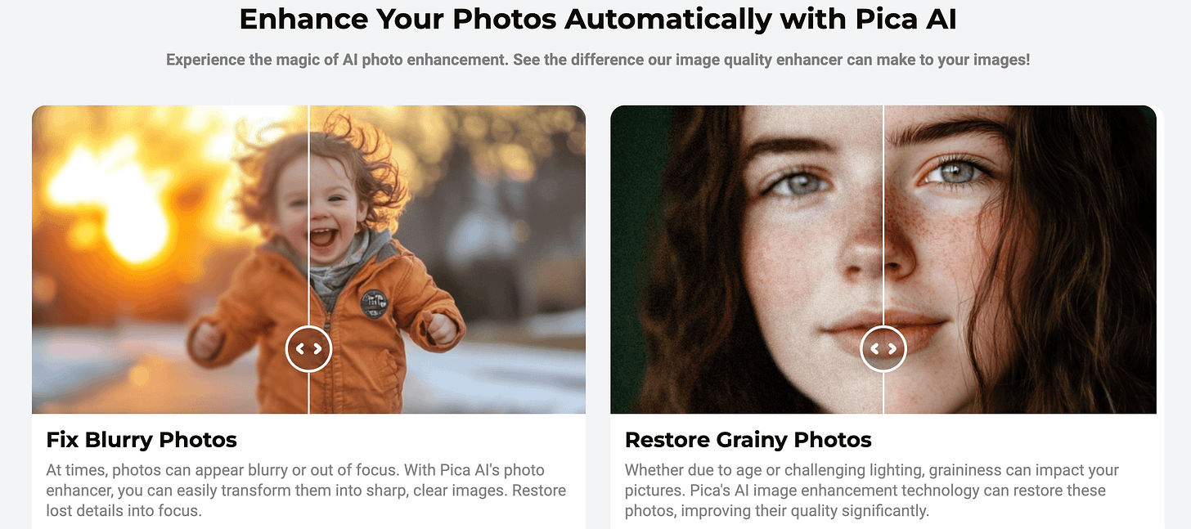

Pica helps you quickly polish up old pictures. You can try it without paying or logging in. Without a subscription, your photos will show a Pica watermark.

Test your AI skills — Google's Odd One Out
Can you spot which object is AI-generated? As the quality of AI imagery improves, it gets trickier. For a different challenge, try Say What You See to try crafting clear prompts.

Learn with an AI tutor — Poe
Chat with — or make — specialized AI bots. You can find a bot to get help with Excel formulas, practice Chinese translation, study anatomy, or generate coloring pages. I crafted a French tutor to translate and explain grammar; a Memory Aid to help with mnemonic devices; and an artist for ink-style drawings. Why I like Poe.

Make your own game — Windsurf Cascade
Code a game or application even if you’ve never programmed. Just ask for help and Windsurf will spin out code so you can start playing. Iterate by requesting adjustments in natural language. For more on why it’s so useful, read my post. Free for a 2-week trial.

Generate an infographic to depict an idea or framework — Napkin AI
Create a quick infographic explaining any concept visually. This AI-powered design tool takes text you give it—or a prompt—and instantly produces multiple visuals for you to select from. Read more about why I find it so useful.

Convert a written note into digital text — ChatGPT
Take a photo of a written note with the app, or upload one from your camera roll. Then copy and paste the digitized text into an email, your digital notebook, or anywhere else you want to use it. I wrote my first draft of this post on paper to avoid screen distractions. ChatGPT’s digitization of my sloppy handwriting was nearly flawless.

Get a briefing on any subject — Perplexity
Get a competitive analysis or a thorough explanation of any complex topic. Perplexity breaks down anything you’re trying to understand or gives you a citation-rich historical summary. Get five free pro searches a day. Concise responses are among the reasons I rely on Perplexity. Read my full take on Perplexity.

Get a free drawing — Ideogram
Use one of the best new image generators to make your own custom illustration of a scene, place, person, or object. Create images in a photographic or illustrated style. Ideogram can also render text accurately within an image. Check out some tips and examples.

Compose a short song with lyrics | Suno
Write a short prompt of up to 200 characters describing the mood and genre of a song you want to generate. You can even pick a subject for its lyrics. Try including the name of a special person, place, or event you want the song to be about. A short song you can download or link to as an audio clip
Example: Here's a song I generated about an American visiting South Africa for the first time.

